- December's rise in UK CPI inflation mainly reflected shifts in volatile core categories and the uprating of tobacco duty taking effect. Headline inflation is projected to soften in the near term, then drop significantly in April due to weaker contributions from the energy and core categories.
- However, some of the factors set to drive inflation lower in H1 are temporary in nature. After a period close to target, we expect inflation to edge up again later this year.
CPI inflation increased to 3.4% in December, from 3.2% in November. Food price inflation rose, but the higher outturn was also payback after November's soft outturns in several notoriously volatile core sub-components, such as clothing, air fares and accommodation services, partially unwound. The 2025 Budget uprating of tobacco duty also raised inflation in December, with the 2024 increase having occurred a month earlier. Elsewhere, RPI and RPIX inflation both rose by 0.4ppts to 4.2% and 4.1% respectively.
The unusually early price collection date in December meant the m/m pickup in air fares was towards the bottom of a range of historical outcomes, so there should be some payback in January. But this is unlikely to disrupt the gentle downward trajectory for inflation expected over the first few months of the new year. The headline rate should then drop significantly in April due to two key factors. First, the contribution from the energy category will fall more than 0.4ppts due to base effects, lower wholesale prices, and the removal of some government levies. Second, April's rise in regulated prices is expected to be smaller than last year's hefty increase, which is likely to weigh heavily on the core category. More broadly, services inflation should also see some downward pressure through the year from weaker pay growth and the fading impacts of the 2025 increases in employers' national insurance contributions and the national living wage.
But given base effects and that some of the factors set to drag on inflation in H1 2026 are likely to prove temporary, we expect the headline rate to slowly edge upwards over the course of H2 2026 and in 2027. We forecast CPI inflation to average 2.3% in 2026 and 2.5% in 2027.
Chart 1: CPI inflation is forecast to average 2.3% in 2026 and 2.5% in 2027
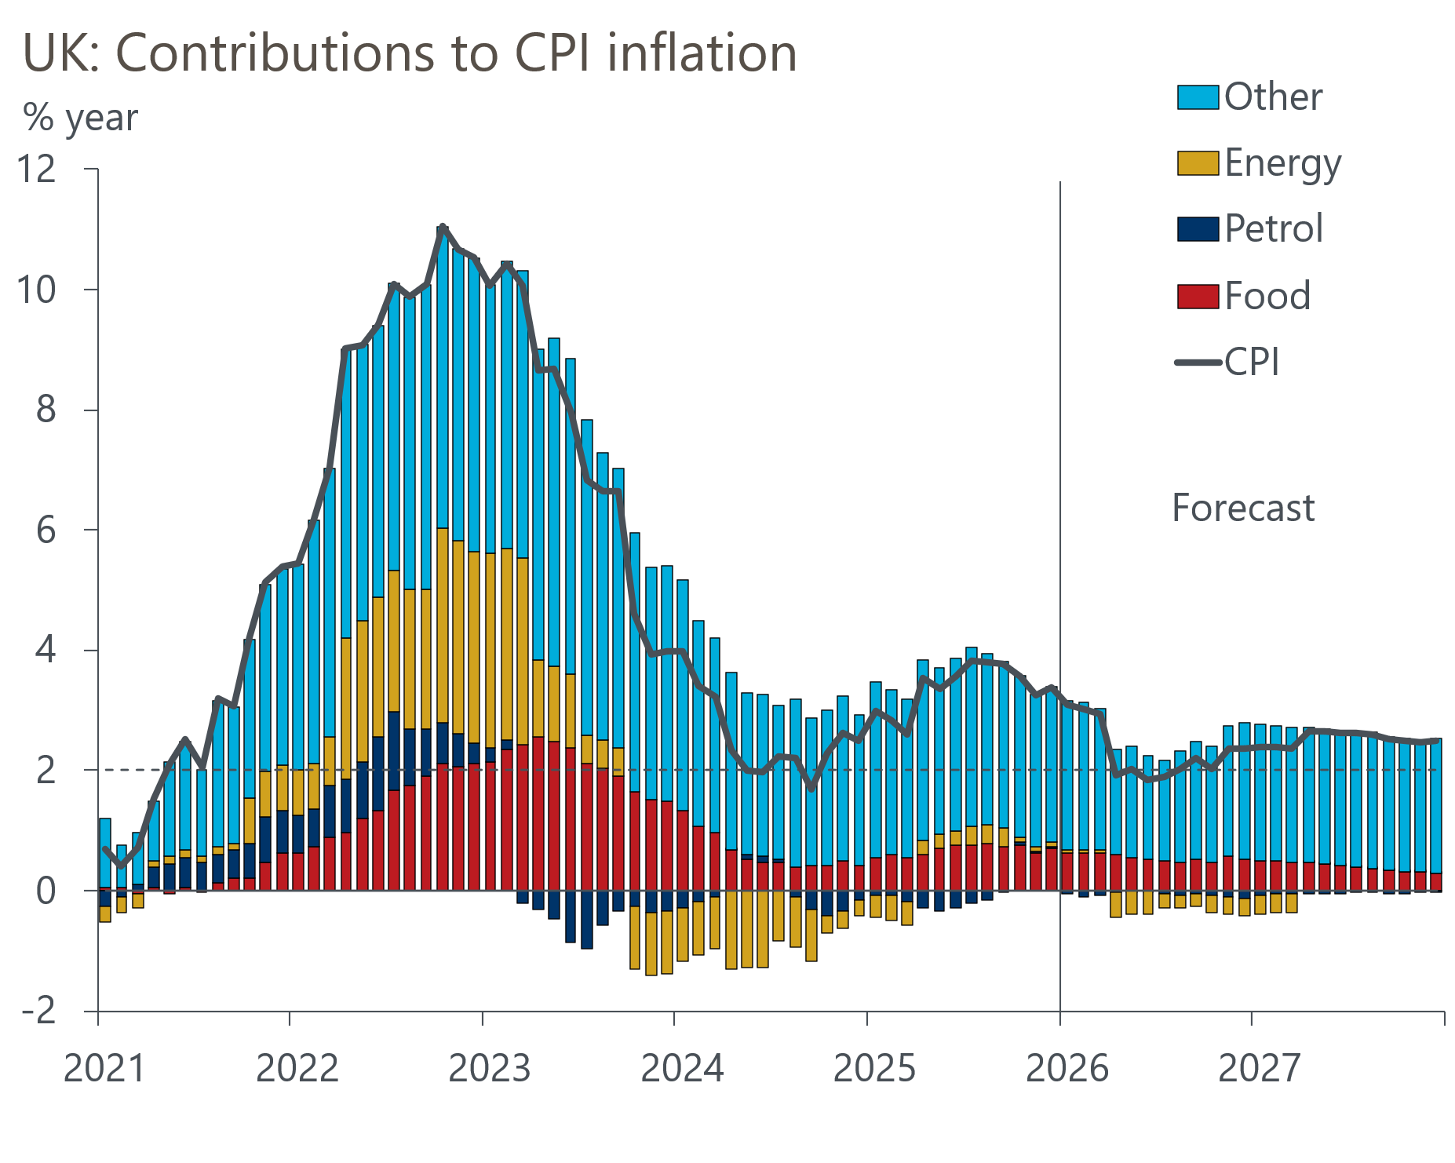
Source: Oxford Economics, Haver Analytics

